AS400 Agency Ingestion Lambda – Technical Documentation
1. Overview
The AS400 Agency Ingestion Lambda is an AWS Lambda service responsible for loading and maintaining Agency data from AS400 source systems into the Data Foundation (DF) RDS Agency table.
It follows the standard ingestion pattern used for other DF entities (e.g., Policy, Invoice, Coverage Allocation) and supports upsert behavior (insert and update) based on the combination of:
- source_agency_id
- source_system
The Lambda is typically triggered by Amazon SQS events and processes each message independently.

2. Supported Source Systems
The Lambda currently supports the following AS400 source systems:
Source System | Description
AS400_AFFPRD | AS400 AFFPRD system
AS400_KKINS | AS400 KKINS system
Each source system uses a dedicated database connection and SQL query suited to its schema and data requirements.

3. High-Level Processing Flow
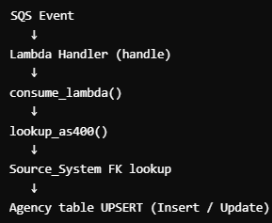
- SQS Event – Triggers the Lambda with one or more messages.
- Lambda Handler (handle) – Orchestrates per-record processing and SQS batch response.
- consume_lambda() – Normalizes input, validates payload, and coordinates ingestion.
- lookup_as400() – Retrieves agency data from the appropriate AS400 system.
- Source System FK Lookup – Resolves df_source_system_id from the Source_System table.
- Agency Upsert – Inserts or updates the DF Agency table based on existence checks.

4. Required Environment Variables
The Lambda uses environment variables to configure RDS and AS400 connections.
4.1 RDS / DF Configuration
- RDS_DB_NAME
- RDS_REF_DB_NAME
- RDS_RAW_DB_NAME
- RDS_REFINED_DB_NAME
- RDS_HOST
- RDS_SECRETS_MANAGER_ID
- AWS_REGION
4.2 AS400 Secrets
- AS400_AFF_SECRETS_MANAGER_ID
- AS400_KKINS_SECRETS_MANAGER_ID
These variables are used to retrieve credentials from AWS Secrets Manager and to establish secure connections to RDS and AS400 systems.

5. Database Connections
5.1 call_session_engine()
The call_session_engine() function is responsible for returning the appropriate SQLAlchemy session or engine depending on the parameters provided.
Behavior:
- Returns an AS400 engine when a source_system is provided.
- Returns an RDS session when a database_name is provided.
This abstraction centralizes connection management and ensures consistent configuration across operations.

6. AS400 Lookup Logic
6.1 lookup_as400(config, id)
The lookup_as400() function retrieves agency data from the appropriate AS400 source system.
Inputs:
- config: Dictionary containing at least source_system.
- id: The source_agency_id for the agency to be retrieved.
Outputs:
- A list of dictionaries representing records returned from AS400.
- None if no records are found.
6.2 AFFPRD Query
For AS400_AFFPRD, the query returns a full agency profile, including (but not limited to):
- Legal name
- DBA (Doing Business As) name
- Tax ID
- Status
- Address information:
  - Premises address
  - Billing address
  - Mailing address
- Contact information:
  - Phone
  - Fax
  - Website
6.3 KKINS Query
For AS400_KKINS, the query retrieves a minimal identifier set, comprised of:
- source_agency_id
- source_system
This system provides basic identifiers and may rely on downstream logic or other systems for enrichment.

7. Core Ingestion Logic
7.1 consume_lambda(config)
The consume_lambda() function orchestras the ingestion process, including:
- Input normalization
- Validation
- AS400 data retrieval
- Foreign key resolution
- Insert or update operations on the DF Agency table
7.1.1 Input Normalization
The function supports multiple input formats and normalizes them into a list of records:
- Single dictionary
- JSON string
- List of dictionaries
7.1.2 Required Field Validation
Each record must contain:
- source_agency_id
- source_system
Records missing these fields are considered invalid and are handled accordingly (e.g., logged and marked as failed).
7.1.3 AS400 Data Retrieval
For each valid record:
- lookup_as400() is called to fetch the corresponding agency data from the appropriate AS400 system, based on source_system.
7.1.4 Source System Foreign Key Lookup
The Lambda performs a lookup on the Source_System table to obtain the df_source_system_id that corresponds to the source_system.
Important:
If the source system does not exist in Source_System, no insert or update is performed for that record.
7.1.5 Existing Agency Lookup
The DF Agency table is queried to determine whether an agency already exists, using:
- source_agency_id
- df_source_system_id
This check enables idempotent upsert behavior.
7.1.6 Insert Logic (New Agency)
If no matching agency record is found:
- A new df_agency_id is generated using generate_uuid().
- created_at is set to the current timestamp.
- A new record is inserted into the Agency table.
7.1.7 Update Logic (Existing Agency)
If an existing agency record is found:
- The original created_at value is preserved.
- modified_at is updated to the current timestamp.
- A SQLAlchemy update() is performed on the Agency table for the identified record.
This ensures idempotent and consistent updates.

8. Lambda Entry Point
8.1 handler(event, context)
The handler() function is the AWS Lambda entry point.
Responsibilities:
- Iterates through SQS Records.
- Extracts and parses each message body.
- Invokes consume_lambda() to process individual messages.
- Tracks failures for SQS partial batch retry compatibility.
8.2 Return Format (SQS-Compatible)
The function returns a response object compatible with SQS partial batch failure handling:
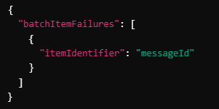
- batchItemFailures contains a list of messageId values corresponding to SQS messages that failed processing.
- Messages not listed are treated as successfully processed and will not be retried by SQS.

9. Error Handling
Lambda includes robust error handling mechanisms:
- Database Errors
  - Caught as SQLAlchemyError.
  - An error, an explicit session rollback is performed.
- Failed Messages
  - Failed SQS records are:
    - Logged with relevant error details.
    - Returned in batchItemFailures for automated SQS retry.
- General Exceptions
  - Logged with stack traces where appropriate to aid debugging.

10. Logging
The Lambda uses the standard Python logging module to capture operational and diagnostic information.
Key logging events include:
- Lambda invocation details (e.g., number of records).
- AS400 fetch status (success, no records, errors).
- Insert and update operations on the Agency table.
- Execution, timing and performance metrics were applicable.
Logging is designed to support:
- Operational monitoring
- Troubleshooting
- Auditability of ingestion behavior

11. Example Event Payload
Below is an example of SQS event payload passed to Lambda:
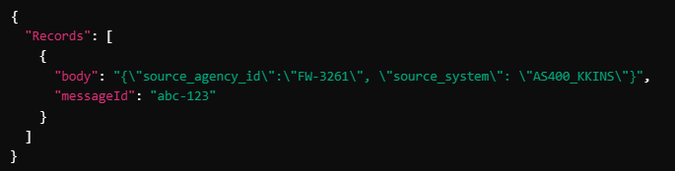
In this example:
- source_agency_id is FW-3261.
- source_system is AS400_KKINS / AS400_AFFPRD.
- messageId (abc-123) is used for tracking and partial batch failure reporting.

